Activity 4.2: Setting the width and layout of elements
Go online and find a suitable image of a birthday cake and save it as birthdayCake.png to your folder.

- Edit 'css' to:
- define the width of the section element. Each small square in the diagram below represents 10% of the width of the screen
- ensure that the figure floats to the right of the screen and is cleared from the article.
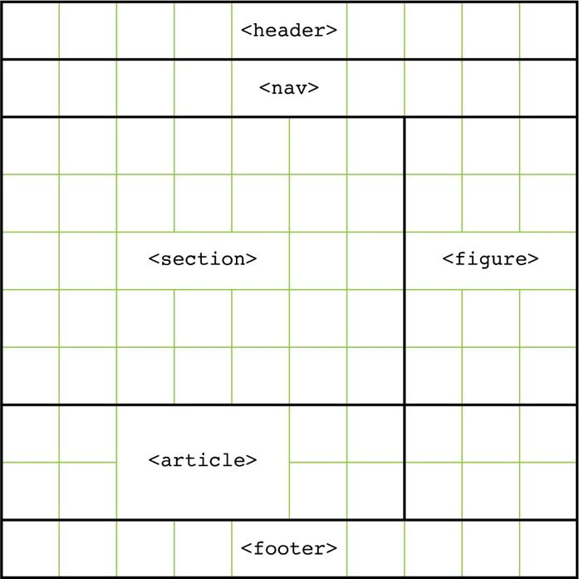
- Once you have edited the style sheet, save it and then open 'lesson4_index.html' in a browser to check that the styling is correct.

Insert a screenshot of the web page and insert it here:

